DAMAGE MODELING · WORKED REFERENCE
Flood × Solar — building the curve, step by step
How the flood × solar damage curves are built across the seven stages: what we do at each stage, why, and the evidence behind every decision — with sources and links. This is the multi-failure-unit companion to the hail × solar reference; where a decision differs from hail, the reason is called out.
Cell: flood_solar Damage code: FLOOD_SOLAR_ELECTRICAL_INUNDATION_V1
Design: multi-failure-unit (inverter · switchgear · transformer · combiner/DC · SCADA · cable · foundation · module).
Status: public-source-derived v1.0 piecewise/state depth-damage package — not private-claims-calibrated.
Where to find more
GitHub repo: aamani-ai/Damage_Modeling
Derivation dossier: flood_solar_curve_derivation_dossier_v1_0.md
Curation notebook: notebooks/flood/solar/00_curve_curation_walkthrough.ipynb
Runtime artifact: flood_solar__model_v1_0__docs_r3__curve_artifact.json
Slide deck: Damage Modeling — From the Basics (Google Slides)

STAGE 0 The modeling question
Decisive question: What are we building a curve for — and why can’t flood be one plant-level number?
Flood is modeled as multiple failure-units, not one whole-plant flood-depth curve. Floodwater does not hit one material surface uniformly — it interacts with each piece of equipment’s elevation, enclosure, conduit path and drainage. Two items at the same site flood depth can see very different local exposure.
NOT: site flood depth -> whole solar plant DR
YES: local depth at each component datum -> per-failure-unit DR
Reference: internal method — 03 · failure-unit coverage standard; solar-specific pathways — DOE/FEMP PV flood guidance

STAGE 1 Evidence
Decisive question: What does the curated evidence base authorize, and what does each source explicitly NOT support?
The v1.0 package is built from six external sources plus two internal ones. The discipline (per the evidence standard) is to record what each source does and does not support — so no source is stretched past its role:
Source | Supports / does NOT support | Role
DOE/FEMP PV flood guidance | Supports solar pathways (submersion, conduit water paths, raising equipment). Not final numeric depth-damage curves. | mechanisms · T2
NEMA GD 1 — Evaluating Water-Damaged Electrical Equipment | Replacement/reconditioning framing for water-exposed electrical gear. Not continuous flood-depth curves. | electrical loss · T2
NEMA GD 1-2016 (open PDF) | Category table: switchgear, breakers, electronics, transformers, cable. Not solar-specific; OEM guidance can supersede. | electrical loss · T2
NEMA enclosure types | Distinguishes rain/hosedown from submersion ratings (Type 6/6P). Rating alone doesn’t set replacement cost. | selector · T2
FEMA / Building America utility-system flood guide | Elevation/protection framing for utility systems. Building-utility context, not bespoke PV curves. | exposure · T3
USACE HEC-FIA depth-percent damage | Supports the tabular depth-percent curve FORM and interpolation. Generic method, not solar values. | curve form · T2
Later evidence co-curation added mechanism support (Ketjoy et al. 2022 module depth-percent; NERC 2022 substation shallow-depth cases; ANZGeo 2023 scour) as validation and future-selector candidates — not as refit v1.0 numbers.
Reference: 08 · evidence, provenance & links standard

STAGE 2 Grain
Decisive question: Which failure-units carry curves, and why is the split broader than hail?
Failure-unit | v1.0 treatment | Why
INVERTER · power electronics | primary curve | DOE/FEMP flags inverters as flood-sensitive; NEMA treats electronics as high-loss once wet.
SUBSTATION / SWITCHGEAR | primary curve | NEMA replacement logic → steep curve after ingress; central grid-connection value.
TRANSFORMER / control area | primary, less vertical | Liquid-filled units may allow evaluation/reconditioning, so the curve rises more gradually.
COMBINER / DC protection | primary curve | Small water-sensitive enclosures with surge/protection devices.
SCADA / control cabinet | primary curve | Electronics/comms are high-loss once wet/contaminated.
Collection cable / conduit | secondary | Wet-location cable may survive; terminations/conduit contamination dominate.
PV module submersion | conditional | Utility modules are usually elevated; material only when water reaches the lower edge.
Foundation / civil scour | separate axis | Different mechanism (velocity/erosion), not cabinet ingress — carried as a proxy.
Everything above the waterline with no alternate ingress path is kept as an explicit DR ≈ 0 record — reviewed, not forgotten.
Reference: 03 · failure-unit coverage standard; DOE/FEMP + NEMA GD 1

STAGE 3 Axis
Decisive question: What indexes damage for each unit — and why not one site flood depth?
The axis is local water depth above each component’s critical datum, plus a secondary velocity/scour proxy for foundations:
electrical ingress: h_i = max(0, WSE - z_i_crit)
foundation/civil: velocity or scour proxy
WSE = water surface elevation at site datum
z_i_crit = component-specific critical elevation
Rejected: a single plant-level depth curve (two items at the same site depth differ by pad height and entry height), and full 2-D depth × duration curves (duration/contamination/salinity matter, but public evidence isn’t dense enough for per-unit 2-D curves in v1 — they are carried as conditioners/open seams).
Reference: 04 · x-axis decision standard; elevation/protection framing — FEMA / Building America

STAGE 4 Form — why this curve shape
Decisive question: What shape do the curves take, and what is the evidence for that shape (not just its parameters)?
Form: piecewise-linear depth-percent (state) curves. Flood electrical damage is threshold/state-like — dry → water reaches the enclosure path → partial ingress/contamination → critical components wet → full submersion — which a tabular depth-percent curve captures better than a smooth fragility curve.
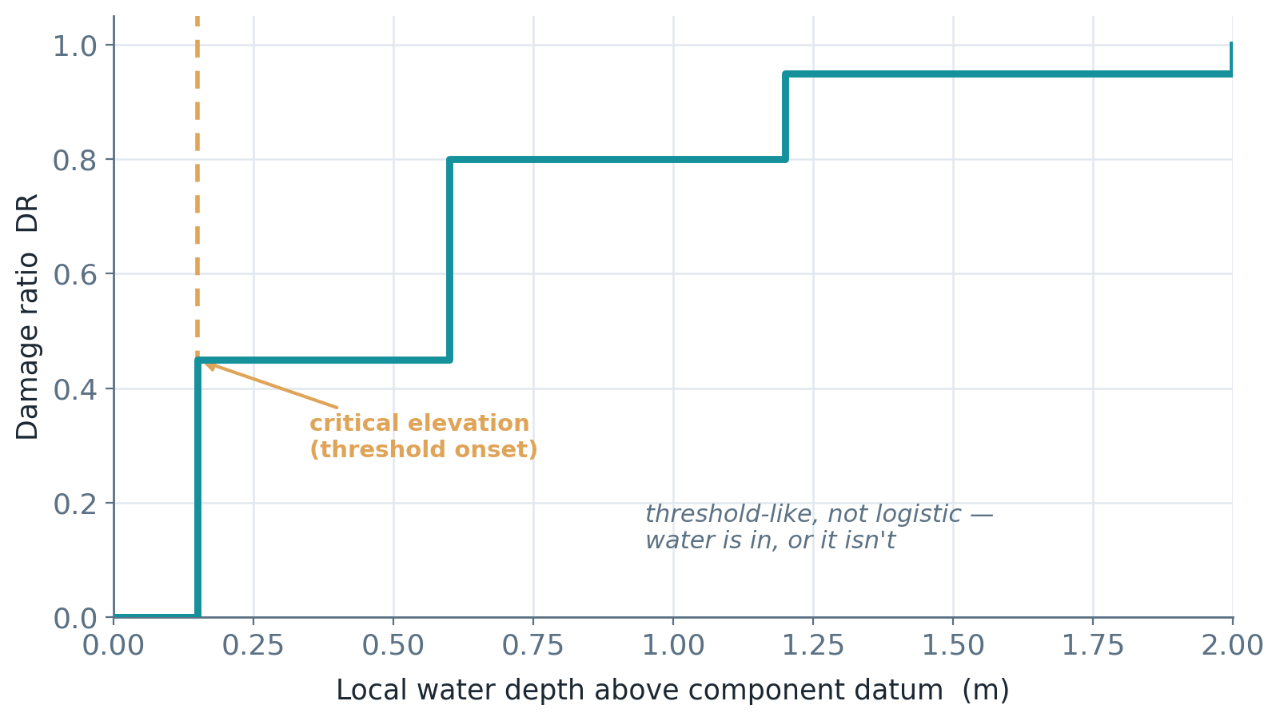
Illustrative inverter curve: near-zero until the critical elevation, then a steep threshold rise — “water is in, or it isn’t.”

Alternatives considered, and why rejected
- Step function — rejected as too brittle; real sites have uncertainty in elevation, sealing and contamination.
- Logistic — rejected as the default; it implies a smooth biological/fragility transition, whereas flood-equipment guidance is threshold/state-based. (Logistic is right for hail glass breakage, which IS a gradual probability in hail size — a deliberate cross-cell contrast.)
- 2-D depth × duration — rejected for v1; insufficient public evidence per unit. Duration/contamination kept as conditioners.
- Piecewise-linear depth-percent — accepted; matches the depth-damage modeling tradition and keeps every threshold auditable.
Reference: internal — 06 · curve form & adjustment standard; external precedent — USACE HEC-FIA depth-percent; depth-damage functions as the established flood convention — Frontiers in Water (2022)

v1.0 curve table (module replacement / equipment DR, %)
Failure-unit (m →) | 0.02 | 0.05 | 0.15 | 0.30 | 0.60 | 1.00 | 2.00
Inverter | 5% | 25% | 75% | 95% | 100% | 100% | 100%
Switchgear | 10% | 40% | 85% | 100% | 100% | 100% | 100%
Transformer/control | 3% | 10% | 25% | 45% | 65% | 80% | 100%
Combiner/DC | 10% | 35% | 80% | 100% | 100% | 100% | 100%
SCADA | 15% | 45% | 90% | 100% | 100% | 100% | 100%
Cable/conduit | 2% | 5% | 10% | 15% | 25% | 40% | 65%
PV module (cond.) | 5% | 10% | 30% | 60% | 85% | 100% | 100%
Shared depth ordinates continue to 1.50 m; the first few centimetres matter because water entry into control sections or cable entries can trigger replacement before deep submersion. Exact intermediate percentages are engineering parameterization (see Caveats).

STAGE 5 Adjustments
Decisive question: What changes the curve besides depth — selector, conditioner, exposure?

Selector — picks a curve variant (fixed metadata)
- enclosure_rating — a Type 6/6P submersion-rated cabinet is a different curve family, not just a value scaling.
- transformer_type — dry-type vs liquid-filled changes replacement logic (a v1.1 selector candidate).
- cable_wet_location_rating — wet-rated cable shifts the collection curve.

Conditioner — event-time state
- energized_state / shutdown_before_flood — energized inundation can increase severity/safety consequences.
- conduit_water_path_present — floodwater can reach elevated equipment through conduit (open-seam modifier).
- duration_hr / contamination_class — shifts reconditioning vs replacement; carried as conditioner/open seam.

Exposure — value, not fragility
fraction_of_component_value_exposed scales affected value (e.g., only half the inverter stations in the flood swath) — it never changes fragility.
Reference: 07 · selector / conditioner / exposure standard; enclosure ratings — NEMA enclosure types

STAGE 6 Emit
Decisive question: What does the cell return per event, and which metrics are honest?
Each failure-unit emits a scalar depth-driven DR (plus curve version, evidence level, and selector/conditioner flags). No within-event spread is carried, so the tail is withheld:
failure-unit scalar DR ............. supported
scenario loss (explicit value basis) supported
scalar EAL ........................ conditional (downstream frequency + cap-binding preflight)
PML / VaR / TVaR .................. withheld (no tail distribution carried)
Reference: 21 · capability & cap-binding standard; 09 · damage-code interface standard

STAGE 7 Ship
Decisive question: What does the consumer receive, and on what terms?
The canonical artifact flood_solar__model_v1_0__docs_r3__curve_artifact.json serializes the piecewise/state curves and the metric gates. The consumer pins the cell-damage-model version and applies value linkage separately:
loss_i = DR_i x value_i x exposure_fraction_i
then EAL / PML / return-period handled downstream, not here
The implementation note names the metadata that actually matters for flood: component critical elevation, pad height/freeboard, module lower-edge elevation, enclosure ratings, transformer type, cable wet-location rating, conduit routing, energized/shutdown state, drainage/defense state, flow velocity.
Reference: 09 · damage-code interface standard

CAVEATS Placeholders & open seams — read before use
Per Prashant’s note, every load-bearing assumption is flagged with why it matters and what would replace it. These are the honest edges of v1.0:
Open seam / placeholder | Why it matters | Update trigger
Foundation / scour velocity proxy (T4) | Site hydraulics/geotech dominate; the generic curve is a placeholder. | Hydraulic model or forensic failure data.
Exact DR % at intermediate depths (T3) | Mechanisms are sourced; the precise percentages are engineering parameterization. | Insurer/claims/OEM/forensic dataset.
Default critical elevations | The local-depth transform h_i controls DR. | Site survey / EPC drawings / digital twin.
Conduit water-path modifier | Can damage equipment even when a cabinet looks elevated. | Electrical one-line, civil grading, conduit layout.
Duration / salinity / contamination | Can shift reconditioning vs replacement. | Source with duration/contamination outcomes.
Enclosure-rating misuse | NEMA 4/4X is not submersion protection (only 6/6P). | Actual enclosure rating & installation details.
Bottom line: v1.0 is a public-source engineering parameterization. The mechanisms and the curve FORM are source-backed; the exact numbers are replaceable placeholders, and the scour axis is explicitly not yet calibrated. It is built so each record can be tightened when claims / OEM / site-engineering evidence arrives.

REFERENCES All sources, with links
Source | What it supports | Tier | Link
DOE/FEMP PV flood guidance | Solar flood pathways; conduit/submersion mechanisms | T2 | open ↗
NEMA GD 1 (water-damaged equipment) | Replacement/reconditioning framing for wet electrical gear | T2 | open ↗
NEMA GD 1-2016 (open PDF) | Category table: switchgear, breakers, electronics, transformers | T2 | open ↗
NEMA enclosure types | Rain/hosedown vs submersion ratings (selector) | T2 | open ↗
FEMA / Building America utility flood guide | Elevation/protection framing for utility systems | T3 | open ↗
USACE HEC-FIA depth-percent damage | The tabular depth-percent curve FORM + interpolation | T2 | open ↗
Frontiers in Water (2022) — depth-damage functions | Depth-damage functions as the established flood convention | context | open ↗
InfraSure method standards (00_global_method) | Governs grain / axis / form / adjustments / evidence / emit | internal | open ↗
Source of truth on GitHub: flood_solar dossier v1.0 · curation notebook · slide deck.

